Functional Block Diagram:

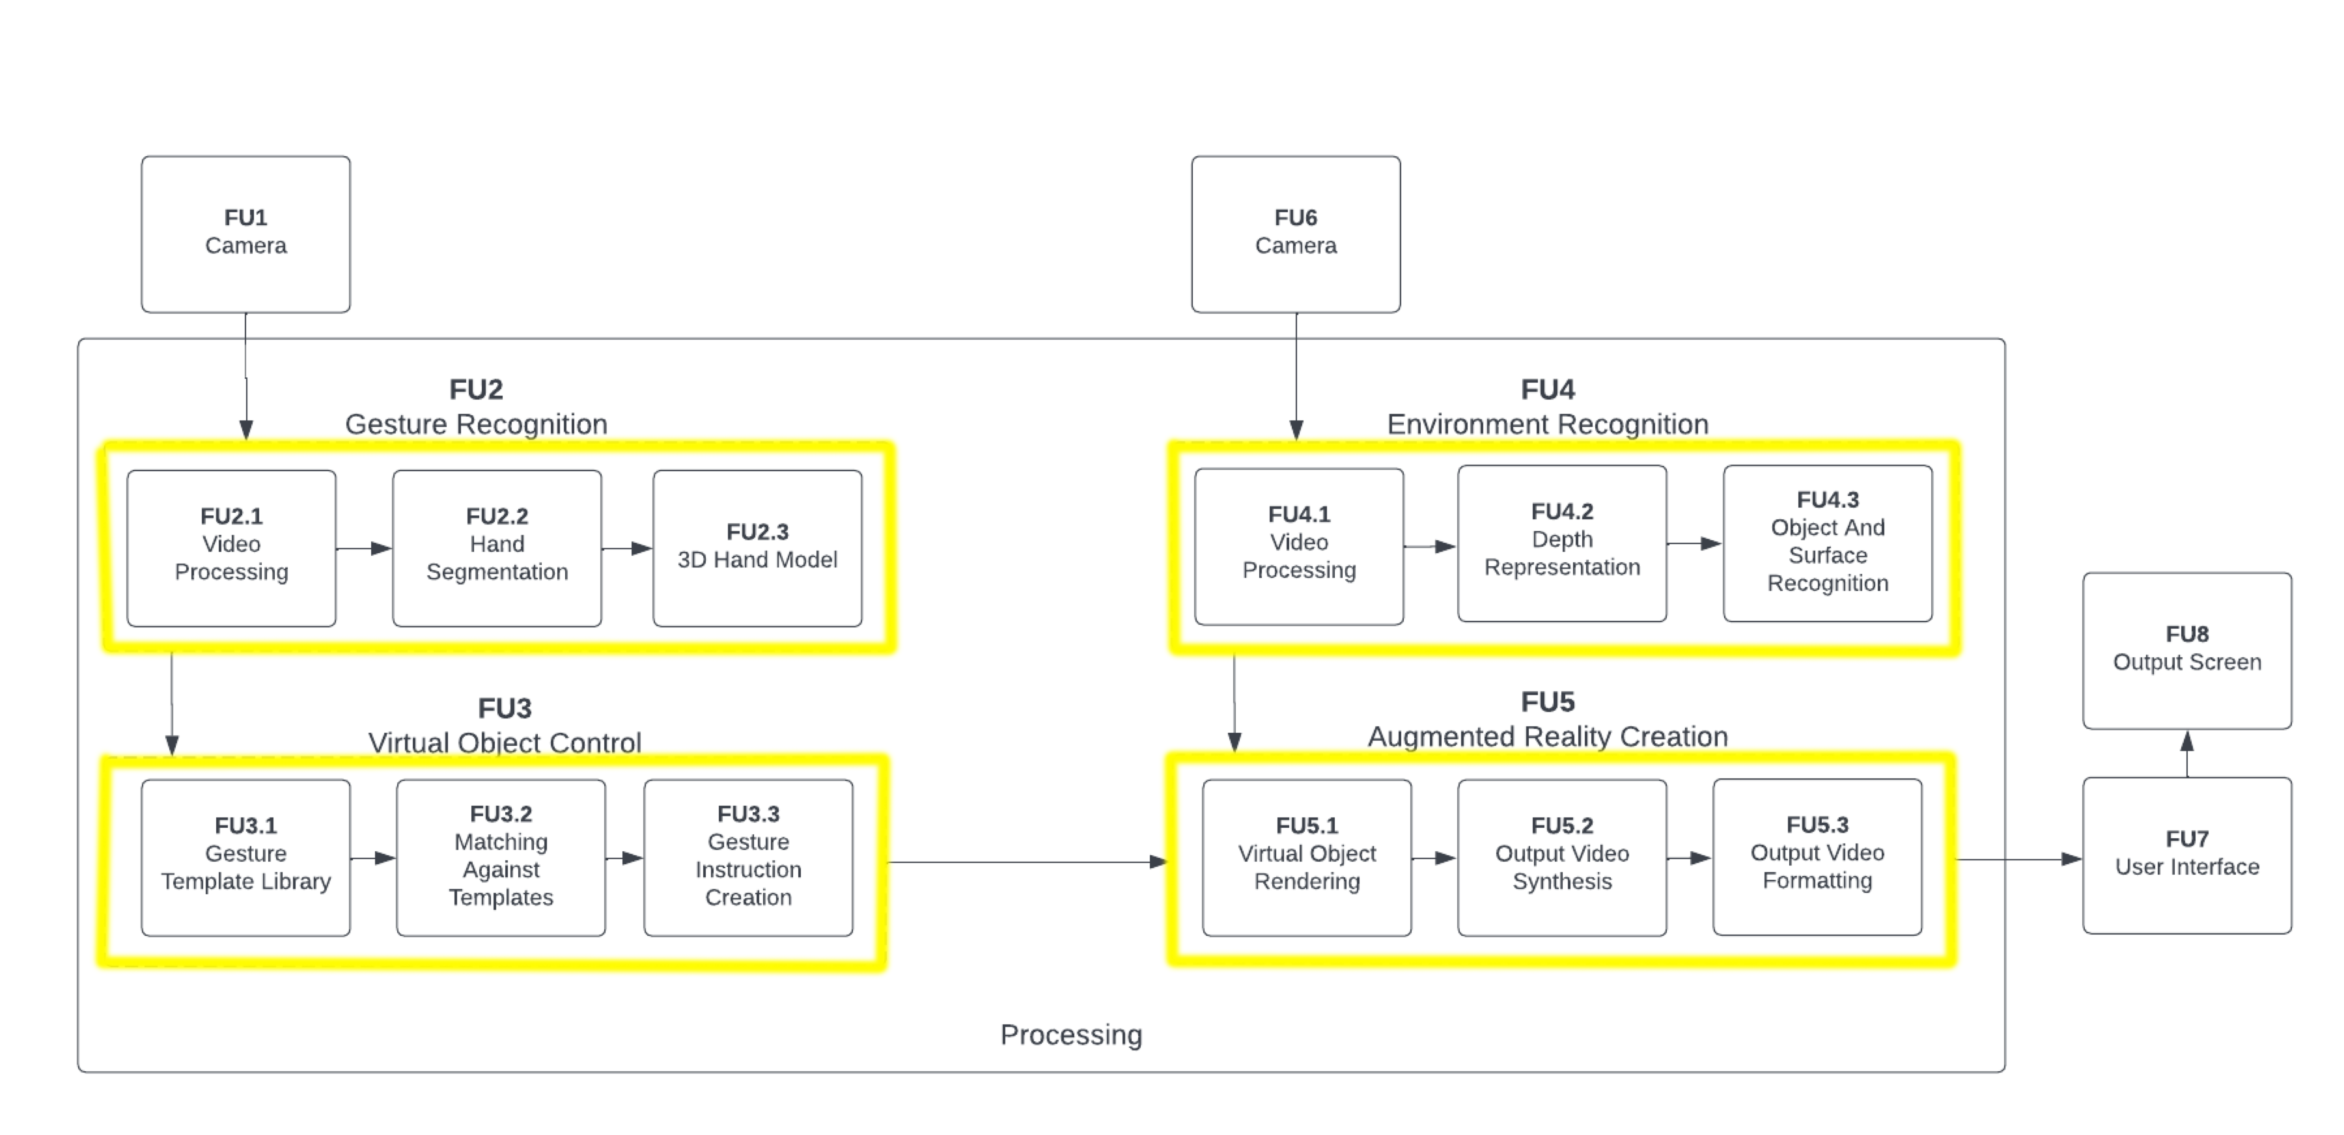

Demo Procedure:

* Showcase pre-calibrated system and result of surface detection algorithm in output window alongside surface normals
* Show colour and hand detection outputs
* Rotate the cube about all 3 axes and show cube movement
* Grab cube and move it 30cm with a fist – showing ability to move it the required distance as well as 30FPS operation
* Attempt to move cube through surface of table and point out surface collision avoidance output
* Place Kinect box on table and attempt to move the cube past the box close to camera and then in-line with the box, showing object detection output and cube stopping behaviour. Remove the box and move the cube through the space
* Point out detected hand rectangle and show precise hand tracking functionality
* Demonstrate system functioning slowly on LattePanda embedded platform + rotation/movement of object at ~ 3FPS